**Lab Session**

1. Create a Navigation menu bar with dropdown list
   1. Create header
   2. Create a nav bar with link 1, link 2, link 3.
      1. When hovering over link 2 and 3, show a drop down menu for each of them with DD_Link_1,DD_Link_2,DD_Link_3
      2. Apply all the required css properties like width, height, hovering properties, etc.,

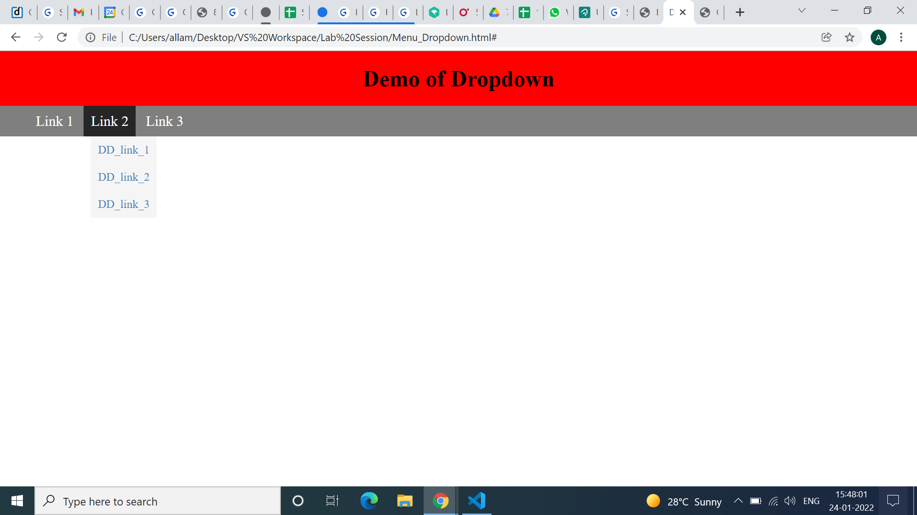

1. Create a vertical bar graph with the help of animation.
   1. when the page is opened/refreshed, the bar should move from bottom to top, to a predefined percentage. Mention the percentage name below. Create 3 such graphs with 30%, 40% and 80%.
   2. Below percentage print h1 with text “Bar Plot”
   3. Position it in the centre of the page.

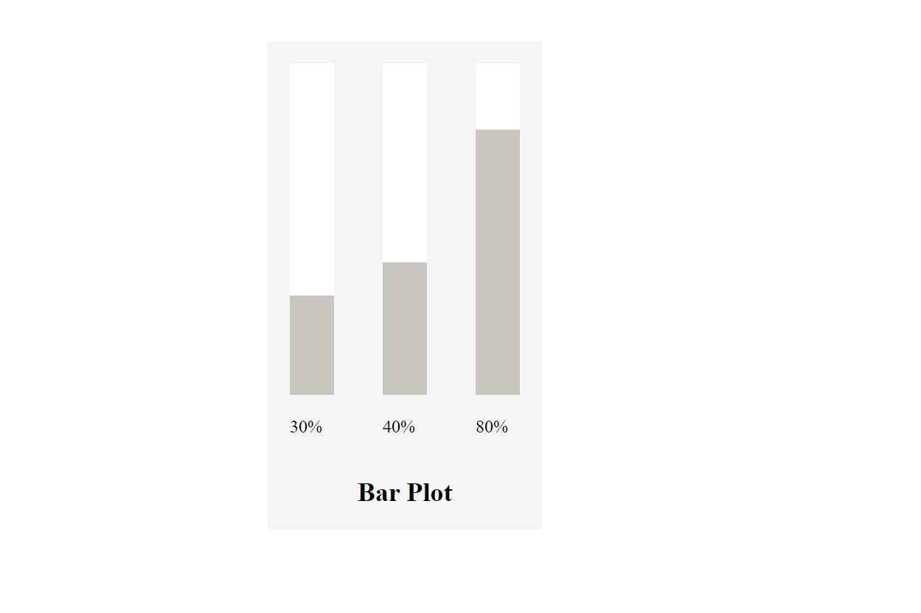

1. Create a gmail account creation form to take input from users as specified below. Take the below image as reference.
   1. Use background image/video for the page and fix it
   2. On focusing input tags change background color to steal blue with opacity 0.35
   3. Add submit and reset buttons
   4. Add border to the form

